|  |  |
| --- | --- |
| *Pacific Gas and Electric Company* | |
| Patch 7.5.6 Installation Guide | |
|  |  |
|  |  |
| Project | ED AM/GIS |
|  |  |
| Prepared by | Corey Blakeborough |
| Date | 7/25/2013 |
| Version | 1.5 |
| Version Type | Final |

|  |  |  |  |
| --- | --- | --- | --- |
| Revision History | | | |
| Document # | Date | Author | Summary of Changes |
| 1.0 | July 24, 2013 | Ashish Narasimham | Initial Document Creation |
| 1.1 | July 24, 2013 | Corey Blakeborough | Detailed Steps for Each Step |
| 1.2 | July 24, 2013 | Ashish Narasimham | Minor corrections after first runthrough of document |
| 1.3 | July 25, 2013 | Ashish Narasimham | Corrected FuseAnno->Size anno class to 8 point font from 8.25 font |
| 1.4 | July 25, 2013 | Ashish Narasimham | Added initial StepdownAnno Changes |
| 1.5 | July 25, 2013 | Ashish Narasimham | Added Stepdown Operating Number and Size annotation class changes |

# Introduction

## Purpose

This document is intended to detail the implementation and configuration steps required to implement the ED AM/GIS 7.5.5 data model release. This document describes the various configuration aspects required to complete any manual or automatic patch associated with this release. Each section in this document contains the steps required to patch the system in production.

## Terms Used

|  |  |
| --- | --- |
| OOTB | Out of the box. Unmodified from the commercial version. |
| TFS | Team Foundation Server |

## TFS Reference

The change requests that constitue the 7.5.5 data model release may be found in TFS using the following information.

|  |  |  |  |
| --- | --- | --- | --- |
| Ticket # | | Work Item Type | Title |
| [9036](http://edappgistfsprd1:8080/tfs/ElectricDistCollection/EDAMGIS/_workitems/edit/9036) | | Change Request | Master Data Model 7.5.6 Patch Release |
| [8585](http://edappgistfsprd1:8080/tfs/ElectricDistCollection/EDAMGIS/_workItems#id=8585&_a=edit) | Change Request | SUBElectricStitchPoint: Change Domain On Field For Subtype |
| [8591](http://edappgistfsprd1:8080/tfs/ElectricDistCollection/EDAMGIS/_workItems#id=8591&_a=edit) | Change Request | SUB Fuse Link Amps: Drop and Re-Create Domain, Add Values To Domain |
| [8587](http://edappgistfsprd1:8080/tfs/ElectricDistCollection/EDAMGIS/_workItems#id=8587&_a=edit) | Change Request | SUBFuse: Change Domain On Field |
| [9056](http://edappgistfsprd1:8080/tfs/ElectricDistCollection/EDAMGIS/_workItems#id=9056&_a=edit) | Change Request | Copy New PGE_CIRCUITCOLOR Table Into EDGISA1T |
| [9020](http://edappgistfsprd1:8080/tfs/ElectricDistCollection/EDAMGIS/_workItems#id=9020&_a=edit) | Change Request | Change TransformerAnno Loadbreak Anno Class Offset and Label Expression |
| [9047](http://edappgistfsprd1:8080/tfs/ElectricDistCollection/EDAMGIS/_workItems#id=9047&_a=edit) | Change Request | Changes To FuseAnno |
| [9049](http://edappgistfsprd1:8080/tfs/ElectricDistCollection/EDAMGIS/_workItems#id=9049&_a=edit) | Change Request | Changes To VoltageRegulatorAnno |
| [9048](http://edappgistfsprd1:8080/tfs/ElectricDistCollection/EDAMGIS/_workItems#id=9048&_a=edit) | Change Request | Changes To SwitchAnno |
| [9046](http://edappgistfsprd1:8080/tfs/ElectricDistCollection/EDAMGIS/_workItems#id=9046&_a=edit) | Change Request | Changes To DynamicProtectiveDeviceAnno |
| [9045](http://edappgistfsprd1:8080/tfs/ElectricDistCollection/EDAMGIS/_workItems#id=9045&_a=edit) | Change Request | Changes To DCRectifierAnno |
| [9043](http://edappgistfsprd1:8080/tfs/ElectricDistCollection/EDAMGIS/_workItems#id=9043&_a=edit) | Change Request | Changes To CapacitorBankAnno |
| [9065](http://edappgistfsprd1:8080/tfs/ElectricDistCollection/EDAMGIS/_workItems#id=9065&_a=edit) | Change Request | Change To SupportStructureAnno |
| [9082](http://edappgistfsprd1:8080/tfs/ElectricDistCollection/EDAMGIS/_workItems#_a=edit&id=9082) | Change Request | Change To StepDownAnno |

## External Documents

Referenced are any external configuration documents or exports. These are documents that contain more detailed information about configuring a system or documents that can be loaded into an application to perform the configuration detailed in this document.

* **PGE_CIRCUITCOLOR** table (inside of a personal geodatabase)  
    
  If connected to the ElectricDistCollection in a TFS Source Control client:  
  $/EDAMGIS/Data Model/Map Production/Stored Displays/Map/EDER/Gold CircuitColor Table  
    
  Via a web client:  
  <http://edappgistfsprd1:8080/tfs/ElectricDistCollection/EDAMGIS/_versionControl#path=%24%2FEDAMGIS%2FData+Model%2FMap+Production%2FStored+Displays%2FMap%2FEDER%2FGold+CircuitColor+Table&_a=contents>
* **Generating Stored Displays** document (to re-reference the PGE_CIRCUITCOLOR table)  
    
  If connected to the ElectricDistCollection in a TFS Source Control client:  
  $/EDAMGIS/Data Model/Map Production/Stored Displays/GeneratingStoredDisplays.doc  
    
  Via a web client:  
  <http://edappgistfsprd1:8080/tfs/ElectricDistCollection/EDAMGIS/_versionControl#path=%24%2FEDAMGIS%2FData+Model%2FMap+Production%2FStored+Displays%2FGeneratingStoredDisplays.doc&_a=contents>

## Summary of Steps to Complete Patch

These are the high-level steps to complete the installation and configuration of the data model patch. Use this table as a guide for completing the installation. Links are provided that can lead either within the document for detailed explanations or to external sites such as Sharepoint.

|  |  |  |  |
| --- | --- | --- | --- |
|  | **Step Name** | **Description** | **Document Link** |
|  | Configure ArcCatalog Connection | Connect to the target database as *edgis* in ArcCatalog, creating a new named connection if necessary. | Set Up ArcCatalog Connection |
|  | SUBElectricStitchPoint: Change Domain On Field For Subtype | Change the domain that a field is assigned for the SUBElectricStitchPoint feature class | Change SUBElectricStitchPoint Domain |
|  | SUB Fuse Link Amps: Drop and Re-Create Domain, Add Values To Domain | Change the type of the domain by dropping/re-creating, add values to the domain | Drop and Re-Create SUB Fuse Link Amps Domain |
|  | SUBFuse: Change Domain on Field | Change the domain that a field is assigned on SUBFuse | Change Domain on Field for SUBFuse |
|  | Copy New PGE_CIRCUITCOLOR Table Into EDGISA1T | Copy the corrected PGE_CIRCUITCOLOR table into A1T | Drop and Re-Add CIRCUITCOLOR Table |
|  | Change TransformerAnno Loadbreak Anno Class Offset and Label Expression | Change annotation properties inside the annotation classes for TransformerAnno | Modify TransformerAnno |
|  | Changes To FuseAnno | Change FuseAnno annotation class annotation properties | Modify FuseAnno |
|  | Changes To VoltageRegulatorAnno | Change VoltageRegulator annotation class annotation properties | Modify VoltageRegulatorAnno |
|  | Changes To SwitchAnno | Change SwitchAnno annotation class annotation properties | Modify SwitchAnno |
|  | Changes To DynamicProtectiveDeviceAnno | Change DynamicProtectiveDeviceAnno annotation class annotation properties | Modify DynamicProtectiveDeviceAnno |
|  | Changes To DCRectifierAnno | Change DCRectifierAnno annotation class annotation properties | Modify DCRectifierAnno |
|  | Changes To CapacitorBankAnno | Change CapacitorBankAnno annotation class annotation properties | Modify CapacitorBankAnno |
|  | Changes To SupportStructureAnno | Change SupportStructureAnno annotation class annotation properties | Modify SupportStructureAnno |
|  | Changes To StepDownAnno | Change StepDownAnno annotation class annotation properties | Modify StepDownAnno |
|  | ArcFM XML Import | Import the ArcFM XML file via ArcCatalog | ArcFM XML Import |
|  | Update Data Model Version Table | Connect to the same server used in step 1 using *SQL Plus* as the edgis user, and run SQL to update the table. | Update Data Model Version Table |
|  | Run Annotation Scripts | Run annotation scripts to update existing features with new anno changes | Run Annotation Scripts |

# Set Up ArcCatalog Connection

Set up a connection in ArcCatalog to use for both automatic and manual patching.

1. Open ArcCatalog.
2. Within the Catalog Tree, expand “Database Connections” and click “Add Spatial Database Connection”.  
     
   
3. Fill in the attributes as shown below. Modify as necessary to reach the correct database.  
     
   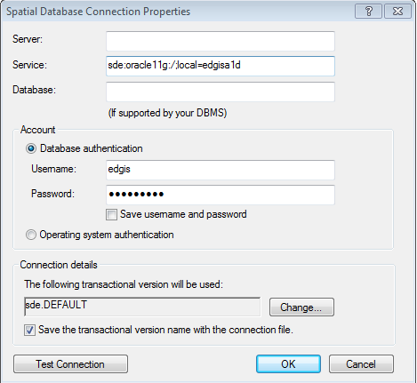

sde:oracle11g:/;local=edgisa1t

1. Click “OK”.
2. The connection will appear on the right side of the window in the Contents tab. Rename the connection appropriately.  
     
   
3. If the full path of this connection is needed, retrieve from in the following default location (path may vary based on installation and operating system):  
   C:\Users\[LAN ID]\AppData\Roaming\ESRI\Desktop10.0\ArcCatalog\[FILENAME].sde
4. Double-click on the connection within ArcCatalog to open it.

# Change SUBElectricStitchPoint Domain

1. Open ArcCatalog.
2. Within the Catalog Tree, expand “Database Connections” and open the active connection for this process (as defined in section 2).
3. Navigate into the SubstationDataset. Right-click on the SUBElectricStitchPoint feature class and click “Properties”.
4. Click on the “Subtypes” tab.
5. 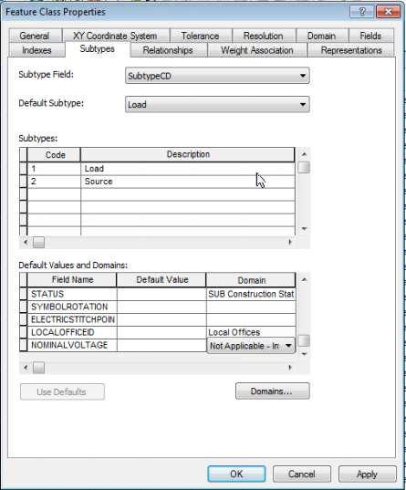Click on the subtype for “Load”.
6. Within the “Default Values and Domains” area, scroll down to the “NOMINALVOLTAGE” field.
7. Click on the domain for this field, and choose the “Not Applicable – Integer” option.
8. Click “OK”.

# Drop and Re-Create SUB Fuse Link Amps Domain

1. Open ArcCatalog.
2. Within the Catalog Tree, expand “Database Connections” and open the active connection for this process (as defined in section 2).
3. Right-click on the connection and click “Properties”.
4. Click on the “Domains” tab.
5. Navigate to the “SUB Fuse Link Amps” domain and click on it in the list.  
     
   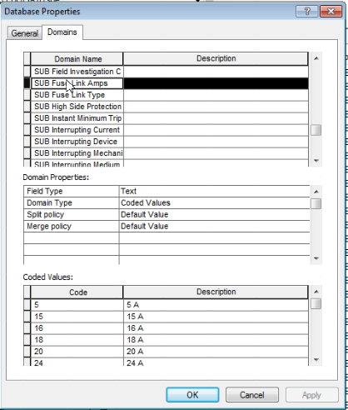
6. Record all existing codes and descriptions (an example is listed in step 10 for ease of use, but be sure to record any differences between the example list and the observed list).
7. Select the domain again in the topmost area, and press the Delete (“Del”) key to delete it.
8. Scroll to the bottom of the list, and use the empty bottom area to recreate the domain.  
   Type the “SUB Fuse Link Amps” domain name into the left side and specify the domain properties as seen below.  
     
   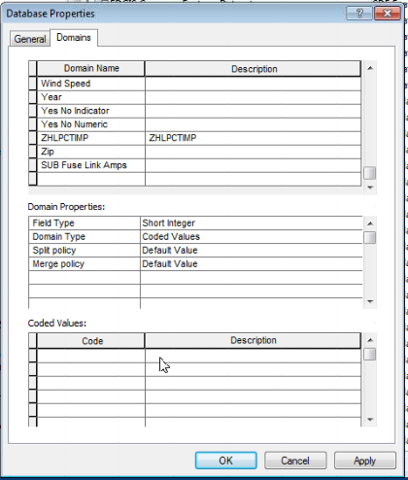
9. In the “Coded Values” section, enter in these new values:

|  |  |
| --- | --- |
| 0 | Unknown |
| -400 | 400X A |
| -560 | 560X A |
| -1 | .5 A |

1. 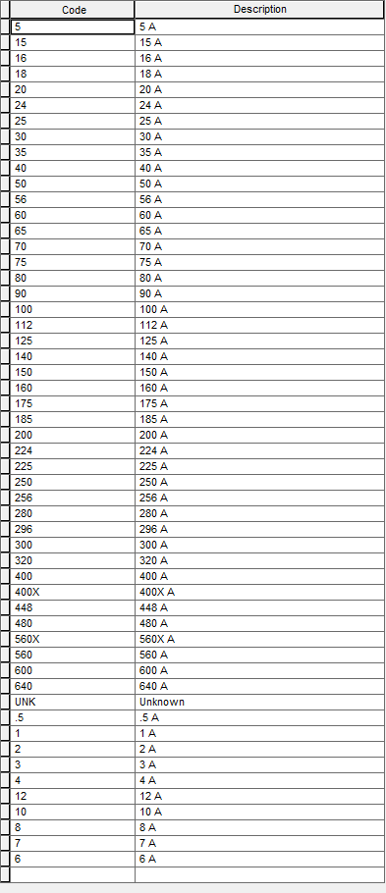Enter in the values that previously existed within this domain. An example of values from the list is provided on the right side of this page.  
   Note: Ignore all old domain codes with an ‘X’ in them, as they have been replaced by the above new domain codes.
2. Click “OK”.

# Change Domain on Field for SUBFuse

1. Open ArcCatalog.
2. Within the Catalog Tree, expand “Database Connections” and open the active connection for this process (as defined in section 2).
3. 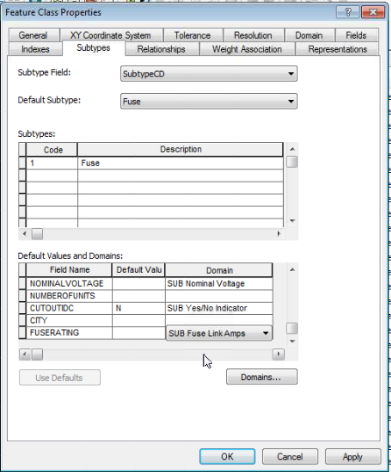Navigate into the SubstationDataset. Right-click on the SUBFuse feature class and click “Properties”.
4. Click on the “Subtypes” tab.
5. Click on the subtype for “Fuse”.
6. Within the “Default Values and Domains” area, scroll down to the “FUSERATING” field.
7. Click on the domain for this field, and choose the “SUB Fuse Link Amps” option.
8. Click “OK”..

# Drop and Re-Add CIRCUITCOLOR Table

1. 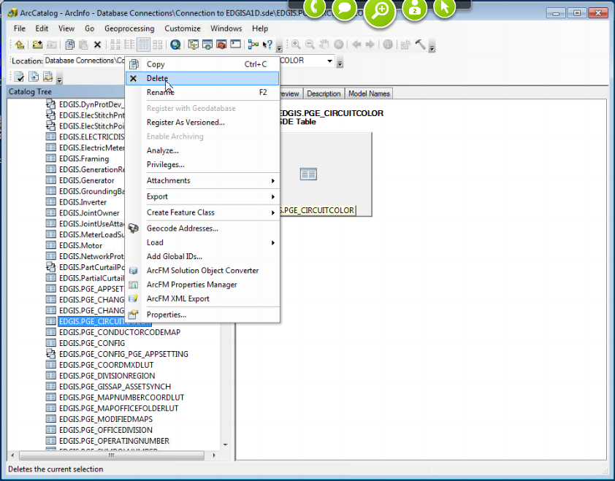Open ArcCatalog.
2. Within the Catalog Tree, expand “Database Connections” and open the active connection for this process (as defined in section 2).
3. Navigate to the EDGIS.PGE_CIRCUITCOLOR table, right-click on the table, and click “Delete”.
4. Obtain the PGE_CIRCUITCOLOR table’s standalone PGDB table from its location within TFS Source Control.  
     
   For more information, see the External Documents section.
5. Create a folder connection to the location where the downloaded file exists

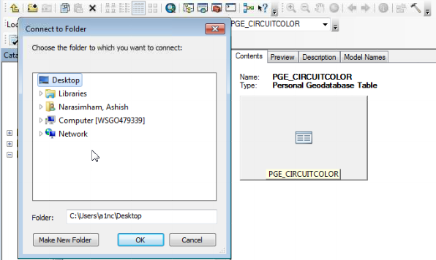

1. Open the personal geodatabase and select the PGE_CIRCUITCOLOR table. Drag and drop the table into the A1D connection. A “Data Transfer” window will appear. Press “OK” to continue.

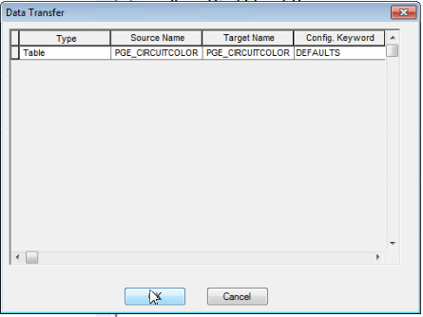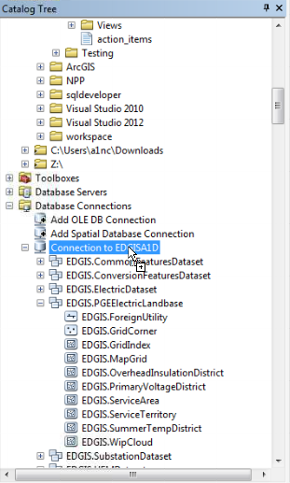

1. Ensure the following privileges:

|  |  |  |
| --- | --- | --- |
| User | View (Select) | Edit (Update/Insert/Delete) |
| sde_editor | GRANT | GRANT |
| sde_viewer | GRANT |  |
| dat_editor | GRANT |  |
| dataconv | GRANT |  |

For each user in the above table, right-click the new EDGIS.PGE_CIRCUITCOLOR table and click “Privileges”. Then enter the field values above (where applicable) into the designated fields and click “OK”.

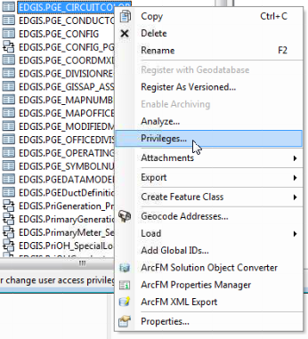  
  
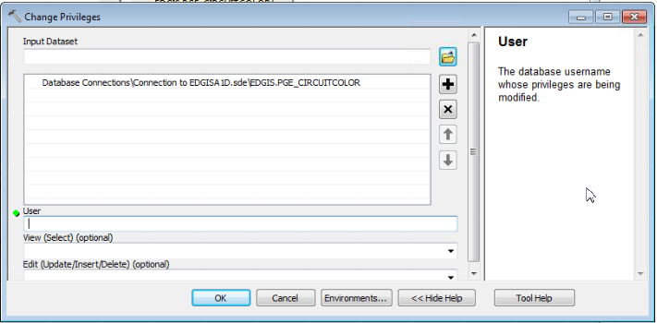

1. Follow the steps in the referenced document to fix the “Circuit Map View” Stored Display to re-reference the new PGE_CIRCUITCOLOR table.

# Modify Annotation Feature Class

## Modify TransformerAnno

1. Open ArcCatalog.
2. Within the Catalog Tree, expand “Database Connections” and open the active connection for this process (as defined in section 2).
3. Within the ElectricDataset, right-click on the “TransformerAnno” annotation feature class and click “Properties”.
4. Click on the “Annotation Classes” tab.
5. Click on the *CGC* annotation class to begin modifying its attributes.  
   1. Under “Text Symbol”, click the “Symbol” button. Then click “Edit Symbol”.
   2. Ensure that the settings under the “General” tab match the example below:  
        
      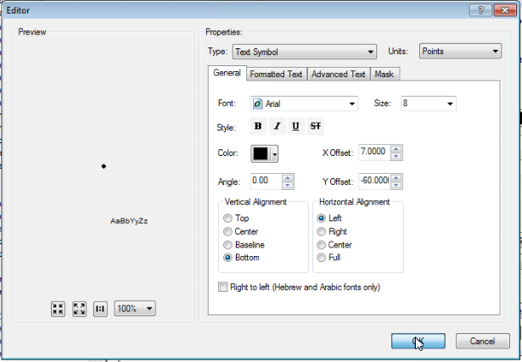
   3. Click “OK” to close this window.
   4. Click “OK” again. If changes were made, read and accept the warning.
   5. Under “Placement Properties”, verify the settings below.  
        
      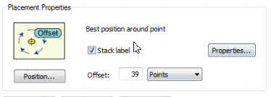
   6. Click “Expression” next to the Label Field dropdown.

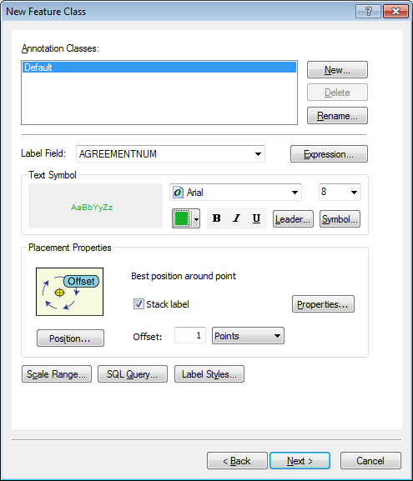

* 1. Ensure that the “Display coded value description” checkbox is **unchecked**.  
     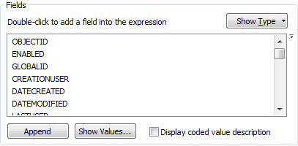
  2. Match the label text with the text below, click verify, and then click “OK”.

Function FindLabel ( [SUBTYPECD], [CGC12], [INSTALLATIONTYPE], [LABELTEXT])

pos1 = InStr (1, [LABELTEXT], chr(10))

if pos1 > 0 then

  pos2 = InStr(pos1 + 1, [LABELTEXT], chr(10))

else

pos2 = -1

end if

if ( pos1 > 0) and (pos2 > 0) and (pos2 - pos1 > 1) then

  lineCount = 3

elseif pos1 > 0 then

  lineCount = 2

else

  lineCount = 1

end if

if  [SUBTYPECD] = 1 or _

  ([SUBTYPECD] = 4 and [INSTALLATIONTYPE] = "OH") or _

   ([SUBTYPECD] = 7 and [INSTALLATIONTYPE] = "OH") or  _

   ([SUBTYPECD] = 8 and [INSTALLATIONTYPE] = "OH") then

  myX = mid([CGC12],4,4)

  myY = mid([CGC12],9,4)

  if LineCount = 3 then

    FindLabel = myX + "-" + myY

  elseif LineCount = 2 then

    FindLabel = myX + "-" + myY + vbCrLf + chr(129)

  else

    FindLabel = myX + "-" + myY + vbCrLf +  chr(129) + vbCrLf +  chr(129)

  end if

end if

End Function

* 1. Click “Apply” but do not close the window.

1. Click on the *Default* annotation class to begin modifying its attributes.  
   1. Under “Text Symbol”, click the “Symbol” button. Then click “Edit Symbol”.
   2. Ensure that the settings under the “General” tab match the example below:  
        
      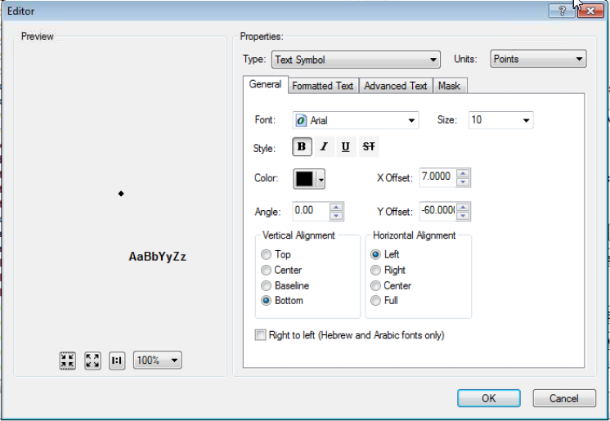
   3. Click “OK” to close this window.
   4. Click “OK” again. If changes were made, read and accept the warning.
   5. Under “Placement Properties”, verify the settings below.  
        
      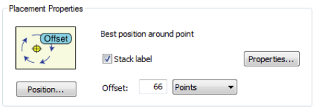
   6. Click “Expression” next to the Label Field dropdown.



* 1. Ensure that the “Display coded value description” checkbox is **unchecked**.  
     
  2. Match the label text with the text below, click verify, and then click “OK”.

Function FindLabel ( [OPERATINGNUMBER], [SUBTYPECD], [INSTALLATIONTYPE] )

if [SUBTYPECD] <> 1 then

if IsNull( [INSTALLATIONTYPE] ) or _

[INSTALLATIONTYPE] <> "OH" then

FindLabel = [OPERATINGNUMBER]

end if

end if

End Function

* 1. Click “Apply” but do not close the window.

1. Click on the *Job* annotation class to begin modifying its attributes.  
   1. Under “Text Symbol”, click the “Symbol” button. Then click “Edit Symbol”.
   2. Ensure that the settings under the “General” tab match the example below:  
        
      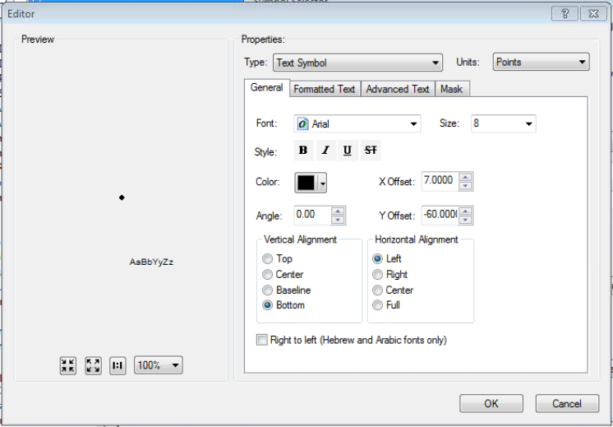
   3. Click “OK” to close this window.
   4. Click “OK” again. If changes were made, read and accept the warning.
   5. Under “Placement Properties”, verify the settings below.  
        
      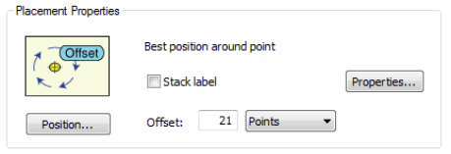
   6. Click “Expression” next to the Label Field dropdown.



* 1. Ensure that the “Display coded value description” checkbox is **unchecked**.  
     

Function FindLabel ( [InstallJobPrefix], [InstallJobNumber], [InstallJobYear], [LABELTEXT], [SUBTYPECD], [INSTALLATIONTYPE], [CGC12])

pos1 = InStr (1, [LABELTEXT], chr(10))

if pos1 > 0 then

pos2 = InStr(pos1 + 1, [LABELTEXT], chr(10))

else

pos2 = -1

end if

if ( pos1 > 0) and (pos2 > 0) and (pos2 - pos1 > 1) then

lineCount = 3

elseif pos1 > 0 then

lineCount = 2

else

lineCount = 1

end if

myString = ""

if isNull( [INSTALLJOBNUMBER] ) or [INSTALLJOBNUMBER] = "0" or _

instr(ucase( [INSTALLJOBNUMBER] ), "CEDSA") then

else

if left(ucase( [INSTALLJOBPREFIX]), 3 ) <> "UNK" and _

ucase( [INSTALLJOBPREFIX] ) <> "FIF" and _

len( [INSTALLJOBPREFIX] ) > 0 then

myString = [INSTALLJOBPREFIX]

end if

if len( [INSTALLJOBYEAR] ) > 0 then

if len( [INSTALLJOBYEAR] ) = 4 then

myString = myString + [INSTALLJOBNUMBER] + " '"+ right( [INSTALLJOBYEAR] ,2)

elseif len( [INSTALLJOBYEAR] ) = 2 then

myString = myString + [INSTALLJOBNUMBER] + " '"+ [INSTALLJOBYEAR]

end if

else

myString = myString + [INSTALLJOBNUMBER]

end if

end if

if [SUBTYPECD] = 1 or _

([SUBTYPECD] = 4 and [INSTALLATIONTYPE] = "OH") or _

([SUBTYPECD] = 7 and [INSTALLATIONTYPE] = "OH") or _

([SUBTYPECD] = 8 and [INSTALLATIONTYPE] = "OH") then

if LineCount = 3 then

FindLabel = myString + vbCrLf + chr(129)

elseif LineCount = 2 then

FindLabel = myString + vbCrLf + chr(129) + vbCrLf + chr(129)

else

FindLabel = myString + vbCrLf + chr(129) + vbCrLf + chr(129) + vbCrLf + chr(129)

end if

else

if LineCount = 3 then

FindLabel = myString + vbCrLf + chr(129)

elseif LineCount = 2 then

FindLabel = myString + vbCrLf + chr(129) + vbCrLf + chr(129)

else

FindLabel = myString + vbCrLf + chr(129) + vbCrLf + chr(129) + vbCrLf + chr(129)

end if

end if

End Function

* 1. Match the label text with the text below, click verify, and then click “OK”.
  2. Click “Apply” but do not close the window.

1. Click on the *LoadBreak* annotation class to begin modifying its attributes.  
   1. Under “Text Symbol”, click the “Symbol” button. Then click “Edit Symbol”.
   2. Ensure that the settings under the “General” tab match the example below:  
        
      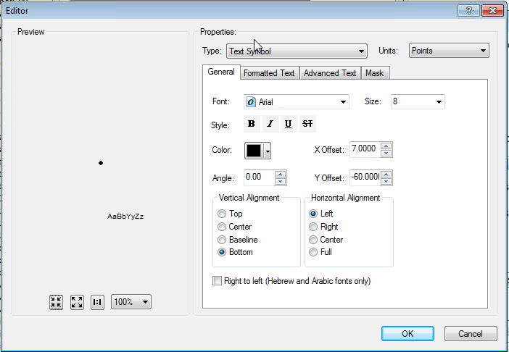
   3. Click “OK” to close this window.
   4. Click “OK” again. If changes were made, read and accept the warning.
   5. Under “Placement Properties”, verify the settings below.  
        
      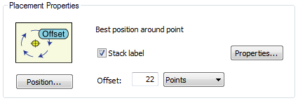
   6. Click “Expression” next to the Label Field dropdown.



* 1. Ensure that the “Display coded value description” checkbox is **unchecked**.  
     
  2. Match the label text with the text below, click verify, and then click “OK”.

Function FindLabel ( [SubtypeCD], [LiveFrontIdc], [LABELTEXT], [INSTALLATIONTYPE], [CGC12] )

If [SubtypeCD] = 2 or [SubtypeCD] = 3 then

pos1 = InStr (1, [LABELTEXT], chr(10))

if pos1 > 0 then

pos2 = InStr(pos1 + 1, [LABELTEXT], chr(10))

else

pos2 = -1

end if

if ( pos1 > 0) and (pos2 > 0) and (pos2 - pos1 > 1) then

lineCount = 3

elseif pos1 > 0 then

lineCount = 2

else

lineCount = 1

end if

if [LiveFrontIdc] = "Y" then

if LineCount = 1 then

FindLabel = "LF" + vbCrLf + chr(129) + vbCrLf + chr(129)

elseif LineCount = 2 then

FindLabel = "LF" + vbCrLf + chr(129)

else

FindLabel = "LF"

end if

End if

End If

End Function

* 1. Click “Apply” but do not close the window.

1. Click on the *Size* annotation class to begin modifying its attributes.  
   1. Under “Text Symbol”, click the “Symbol” button. Then click “Edit Symbol”.
   2. Ensure that the settings under the “General” tab match the example below:  
        
      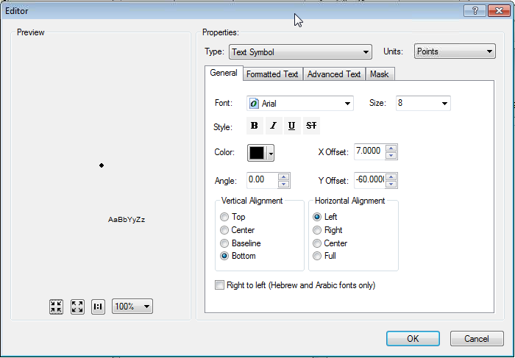
   3. Click “OK” to close this window.
   4. Click “OK” again. If changes were made, read and accept the warning.
   5. Under “Placement Properties”, verify the settings below.  
        
      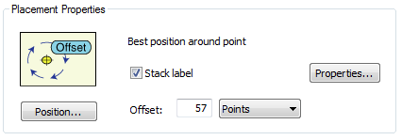
   6. Click “Expression” next to the Label Field dropdown.



* 1. Ensure that the “Display coded value description” checkbox is **unchecked**.  
     
  2. Match the label text with the text below, click verify, and then click “OK”.

Function FindLabel ( [LABELTEXT], [SUBTYPECD], [INSTALLATIONTYPE] )

if [SUBTYPECD] = 1 or _

([SUBTYPECD] = 4 and [INSTALLATIONTYPE] = "OH") or _

([SUBTYPECD] = 7 and [INSTALLATIONTYPE] = "OH") or _

([SUBTYPECD] = 8 and [INSTALLATIONTYPE] = "OH") then

FindLabel = chr(129) + vbCrLf + [LABELTEXT] + vbCrLf + chr(129)

else

FindLabel = chr(129) + vbCrLf + [LABELTEXT]

end if

FindLabel = replace(FindLabel, chr(10) + " ", chr(10))

End Function

* 1. Click “Apply” and “OK”.

## Modify CapacitorBankAnno

1. Open ArcCatalog.
2. Within the Catalog Tree, expand “Database Connections” and open the active connection for this process (as defined in section 2).
3. Within the ElectricDataset, right-click on the “CapacitorBankAnno” annotation feature class and click “Properties”.
4. Click on the “Annotation Classes” tab.
5. Click on the *Default* annotation class to begin modifying its attributes.  
   1. Under “Text Symbol”, click the “Symbol” button. Then click “Edit Symbol”.
   2. Ensure that the settings under the “General” tab match the example below:  
        
      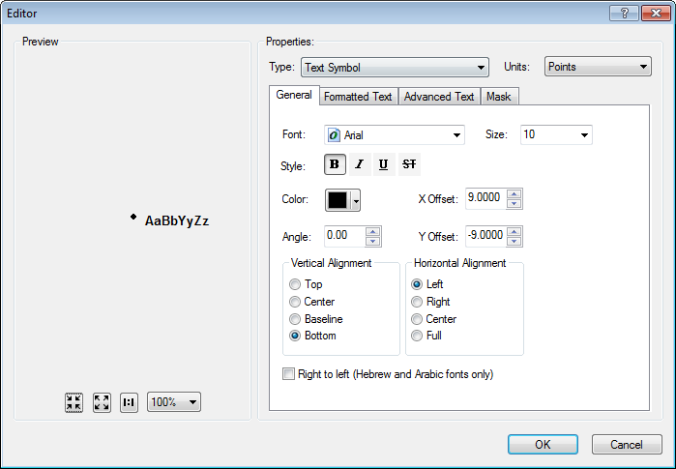
   3. Click “OK” to close this window.
   4. Click “OK” again. If changes were made, read and accept the warning.
   5. Under “Placement Properties”, verify the settings below.  
        
      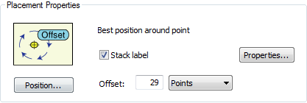
   6. Click “Apply” but do not close the window.
6. Click on the *Job* annotation class to begin modifying its attributes.  
   1. Under “Text Symbol”, click the “Symbol” button. Then click “Edit Symbol”.
   2. Ensure that the settings under the “General” tab match the example below:  
        
      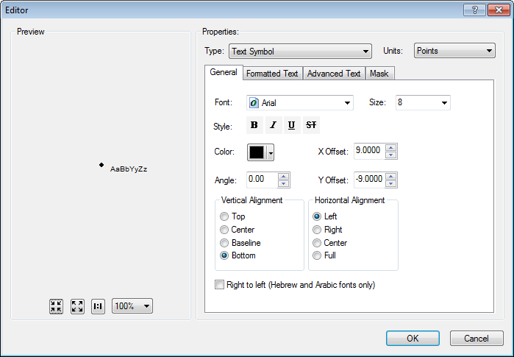
   3. Click “OK” to close this window.
   4. Click “OK” again. If changes were made, read and accept the warning.
   5. Under “Placement Properties”, verify the settings below.  
        
      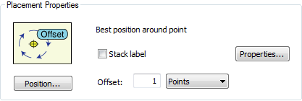
   6. Click “Expression” next to the Label Field dropdown.



* 1. Ensure that the “Display coded value description” checkbox is selected  
     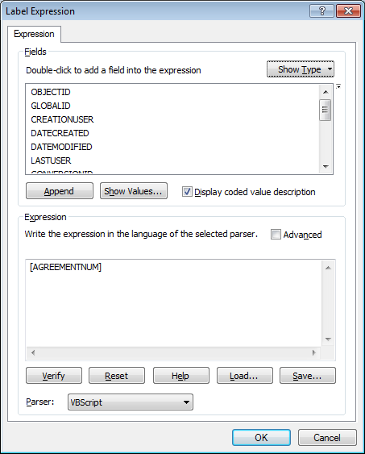
  2. Match the label text with the text below, click verify, and then click “OK”.

Function FindLabel ( [INSTALLJOBPREFIX] , [INSTALLJOBNUMBER] , [INSTALLJOBYEAR] )

myString = ""

if isNull( [INSTALLJOBNUMBER] ) or [INSTALLJOBNUMBER] = "0" or _

instr(ucase( [INSTALLJOBNUMBER] ), "CEDSA") then

else

if left(ucase( [INSTALLJOBPREFIX] ), 3) <> "UNK" and ucase( [INSTALLJOBPREFIX] ) <> "FIF" and _

len( [INSTALLJOBPREFIX] ) > 0 then

myString = [INSTALLJOBPREFIX]

end if

if len( [INSTALLJOBYEAR] ) > 0 then

if len( [INSTALLJOBYEAR] ) = 4 then

FindLabel = myString + [INSTALLJOBNUMBER] + " '"+ right( [INSTALLJOBYEAR] ,2) + vbCrLf + chr(129)

elseif len( [INSTALLJOBYEAR] ) = 2 then

FindLabel = myString + [INSTALLJOBNUMBER] + " '"+ [INSTALLJOBYEAR] + vbCrLf + chr(129)

end if

else

FindLabel = myString + [INSTALLJOBNUMBER] + vbCrLf + chr(129)

end if

end if

End Function

* 1. Click “Apply” but do not close the window.

1. Click on the *Size* annotation class to begin modifying its attributes.  
   1. Under “Text Symbol”, click the “Symbol” button. Then click “Edit Symbol”.
   2. Ensure that the settings under the “General” tab match the example below:  
        
      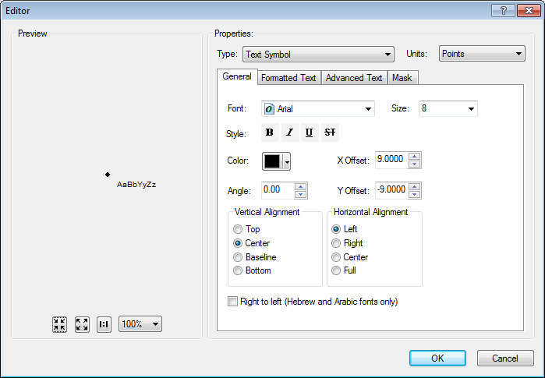
   3. Click “OK” to close this window.
   4. Click “OK” again. If changes were made, read and accept the warning.
   5. Under “Placement Properties”, verify the settings below.  
        
      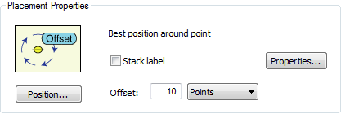
   6. Click “Expression” next to the Label Field dropdown.



* 1. Ensure that the “Display coded value description” checkbox is selected  
     
  2. Match the label text with the text below, click verify, and then click “OK”.

Function FindLabel ( [TotalKVAR], [SubtypeCD] )

dim myVar

MyTotalKVAR = [TotalKVAR]

if [SubtypeCD] = "Fixed Bank Capacitor" then

myVar = "F"

else

myVar = "S"

end if

if ([SubtypeCD] = "Fixed Bank Capacitor" or [SubtypeCD] = "Switched Bank Capacitor") then

FindLabel = [TotalKVAR] + myVar + vbCrLf + chr(129)

else

FindLabel = [TotalKVAR] + vbCrLf + chr(129)

end if

End Function

* 1. Click “Apply” and “OK”.

## Modify DCRectifierAnno

1. Open ArcCatalog.
2. Within the Catalog Tree, expand “Database Connections” and open the active connection for this process (as defined in section 2).
3. Within the ElectricDataset, right-click on the “DCRectifierAnno” annotation feature class and click “Properties”.
4. Click on the “Annotation Classes” tab.
5. Click on the *Job* annotation class to begin modifying its attributes.
6. Under “Text Symbol”, click the “Symbol” button. Then click “Edit Symbol”.
7. Ensure that the settings under the “General” tab match the example below:  
     
   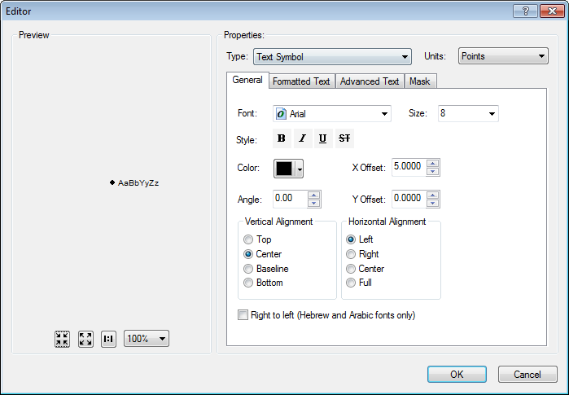
8. Click “OK” to close this window.
9. Click “OK” again. If changes were made, read and accept the warning.
10. Under “Placement Properties”, verify the settings below.  
      
    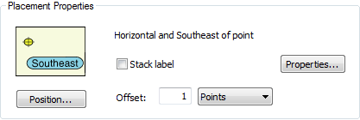
11. Click “Expression” next to the Label Field dropdown.



1. Ensure that the “Display coded value description” checkbox is selected  
   
2. Match the label text with the text below, click verify, and then click “OK”.

Function FindLabel ( [INSTALLJOBPREFIX] , [INSTALLJOBNUMBER] , [INSTALLJOBYEAR] )

myString = ""

if isNull( [INSTALLJOBNUMBER] ) or [INSTALLJOBNUMBER] = "0" or _

instr(ucase( [INSTALLJOBNUMBER] ), "CEDSA") then

else

if left(ucase( [INSTALLJOBPREFIX]), 3 ) <> "UNK" and _

ucase( [INSTALLJOBPREFIX] ) <> "FIF" and _

len( [INSTALLJOBPREFIX] ) > 0 then

myString = [INSTALLJOBPREFIX]

end if

if len( [INSTALLJOBYEAR] ) > 0 then

if len( [INSTALLJOBYEAR] ) = 4 then

FindLabel = myString + [INSTALLJOBNUMBER] + " '"+ right( [INSTALLJOBYEAR] ,2) +vbCrLf + chr(129)

elseif len( [INSTALLJOBYEAR] ) = 2 then

FindLabel = myString + [INSTALLJOBNUMBER] + " '"+ [INSTALLJOBYEAR] +vbCrLf + chr(129)

end if

else

FindLabel = myString + [INSTALLJOBNUMBER] +vbCrLf + chr(129)

end if

end if

End Function

1. Click “Apply” and “OK”.

## Modify DynamicProtectiveDeviceAnno

1. Open ArcCatalog.
2. Within the Catalog Tree, expand “Database Connections” and open the active connection for this process (as defined in section 2).
3. Within the ElectricDataset, right-click on the “DynamicProtectiveDeviceAnno” annotation feature class and click “Properties”.
4. Click on the “Annotation Classes” tab.
5. Click on the *Job* annotation class to begin modifying its attributes.  
   1. Under “Text Symbol”, click the “Symbol” button. Then click “Edit Symbol”.
   2. Ensure that the settings under the “General” tab match the example below:  
        
      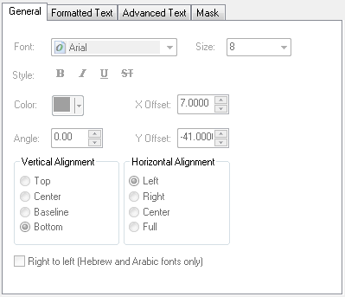
   3. Click “OK” to close this window.
   4. Click “OK” again. If changes were made, read and accept the warning.
   5. Under “Placement Properties”, verify the settings below.  
        
      
   6. Click “Expression” next to the Label Field dropdown.



* 1. Ensure that the “Display coded value description” checkbox is selected  
     
  2. Match the label text with the text below, click verify, and then click “OK”.

Function FindLabel ( [InstallJobPrefix], [InstallJobNumber], [InstallJobYear], [SUBTYPECD], [SWITCHMODEIDC] )

myString = ""

if isNull( [INSTALLJOBNUMBER] ) or [INSTALLJOBNUMBER] = "0" or _

instr(ucase( [INSTALLJOBNUMBER] ), "CEDSA") then

else

if left(ucase( [INSTALLJOBPREFIX]), 3 ) <> "UNK" and _

ucase( [INSTALLJOBPREFIX] ) <> "FIF" and _

len( [INSTALLJOBPREFIX] ) > 0 then

myString = [INSTALLJOBPREFIX]

end if

if len( [INSTALLJOBYEAR] ) > 0 then

if len( [INSTALLJOBYEAR] ) = 4 then

myString = myString + [INSTALLJOBNUMBER] + " '"+ right( [INSTALLJOBYEAR] ,2)

elseif len( [INSTALLJOBYEAR] ) = 2 then

myString = myString + [INSTALLJOBNUMBER] + " '"+ [INSTALLJOBYEAR]

end if

else

myString = myString + [INSTALLJOBNUMBER]

end if

end if

If [SubtypeCD] = "Recloser" or [SubtypeCD] = "Sectionalizer" or [SubtypeCD] = "Interrupter" then

If [SubtypeCD] <> "Interrupter" or [SWITCHMODEIDC] <> "Yes" or isNull( [SWITCHMODEIDC] ) then

FindLabel = myString + vbCrLf + chr(129) + vbCrLf + chr(129)

else

FindLabel = myString + vbCrLf + chr(129)

end if

else

FindLabel = myString + vbCrLf + chr(129) + vbCrLf + chr(129) + vbCrLf + chr(129)

end if

End Function

* 1. Click “Apply” and “OK”.

## Modify FuseAnno

1. Open ArcCatalog.
2. Within the Catalog Tree, expand “Database Connections” and open the active connection for this process (as defined in section 2).
3. Within the ElectricDataset, right-click on the “FuseAnno” annotation feature class and click “Properties”.
4. Click on the “Annotation Classes” tab.  
   .
5. Click on the *Default* annotation class to begin modifying its attributes.  
   1. Under “Text Symbol”, click the “Symbol” button. Then click “Edit Symbol”.
   2. Ensure that the settings under the “General” tab match the example below:   
        
      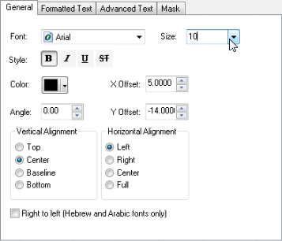
   3. Click “OK” to close this window.
   4. Click “OK” again. If changes were made, read and accept the warning.
   5. Under “Placement Properties”, verify the settings below.   
        
      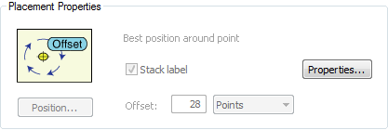
   6. Click “Apply” but do not close the window.
6. Click on the *Job* annotation class to begin modifying its attributes.  
   1. Under “Text Symbol”, click the “Symbol” button. Then click “Edit Symbol”.
   2. Ensure that the settings under the “General” tab match the example below: (note: grayed text still represents correct values)  
        
      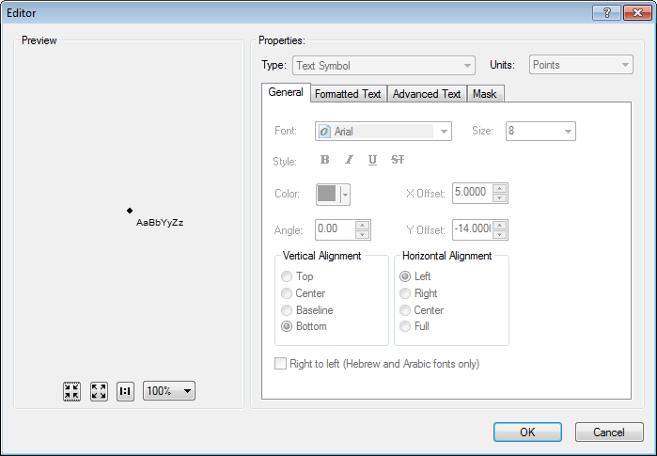
   3. Click “OK” to close this window.
   4. Click “OK” again. If changes were made, read and accept the warning.
   5. Under “Placement Properties”, verify the settings below.   
        
      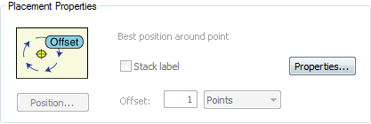
   6. Click “Expression” next to the Label Field dropdown.



* 1. Ensure that the “Display coded value description” checkbox is selected  
     
  2. Match the label text with the text below, click verify, and then click “OK”.

Function FindLabel ( [INSTALLJOBPREFIX], [INSTALLJOBNUMBER], [INSTALLJOBYEAR], [LINKTYPE], [LINKRATING] )

myString = ""

if isNull( [INSTALLJOBNUMBER] ) or [INSTALLJOBNUMBER] = "0" or _

instr(ucase( [INSTALLJOBNUMBER] ), "CEDSA") then

else

if left(ucase( [INSTALLJOBPREFIX]), 3 ) <> "UNK" and _

ucase( [INSTALLJOBPREFIX] ) <> "FIF" and _

len( [INSTALLJOBPREFIX] ) > 0 then

myString = [INSTALLJOBPREFIX]

end if

if len( [INSTALLJOBYEAR] ) > 0 then

if len( [INSTALLJOBYEAR] ) = 4 then

FindLabel = myString + [INSTALLJOBNUMBER] + " '"+ right( [INSTALLJOBYEAR] ,2) + vbCrLf + chr(129)

elseif len( [INSTALLJOBYEAR] ) = 2 then

FindLabel = myString + [INSTALLJOBNUMBER] + " '"+ [INSTALLJOBYEAR] + vbCrLf + chr(129)

end if

else

FindLabel = myString + [INSTALLJOBNUMBER] + vbCrLf + chr(129)

end if

end if

if (uCase([LINKTYPE]) = "UNSPECIFIED" or uCase( [LINKTYPE] ) = "NOT ON LIST") and [LINKRATING] = "9999 A" then

FindLabel = FindLabel + vbCrLf + chr(129)

end if

End Function

* 1. Click “Apply” but do not close the window.

1. Click on the *Size* annotation class to begin modifying its attributes.  
   1. Under “Text Symbol”, click the “Symbol” button. Then click “Edit Symbol”.
   2. Ensure that the settings under the “General” tab match the example below:  
        
      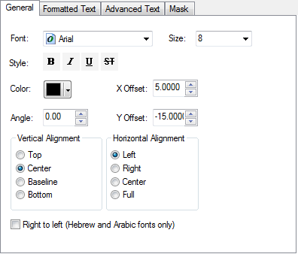
   3. Click “OK” to close this window.
   4. Click “OK” again. If changes were made, read and accept the warning.
   5. Under “Placement Properties”, verify the settings below.   
        
      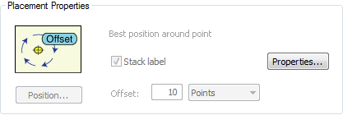
   6. Click “Expression” next to the Label Field dropdown.



* 1. Ensure that the “Display coded value description” checkbox is selected  
     
  2. Match the label text with the text below, click verify, and then click “OK”.

Function FindLabel ( [LinkRating], [LinkType])

myLink = ""

if uCase([LINKTYPE]) <> "UNSPECIFIED" and uCase( [LINKTYPE] ) <> "NOT ON LIST" then

myLink = [LINKTYPE]

end if

myRatinglen = len([LinkRating]) - 2

myRating = mid([LinkRating],1,myRatinglen)

if myRating = "9999" then

myRating = ""

end if

myLabel = myRating + myLink

if len(myLabel) > 0 then

FindLabel = myLabel + vbCrLf + chr(129)

end if

End Function

* 1. Click “Apply” and “OK”.

## Modify SwitchAnno

1. Open ArcCatalog.
2. Within the Catalog Tree, expand “Database Connections” and open the active connection for this process (as defined in section 2).
3. Within the ElectricDataset, right-click on the “SwitchAnno” annotation feature class and click “Properties”.
4. Click on the “Annotation Classes” tab.  
   .
5. Click on the *CCRating* annotation class to begin modifying its attributes.  
   1. Under “Text Symbol”, click the “Symbol” button. Then click “Edit Symbol”.
   2. Ensure that the settings under the “General” tab match the example below:   
        
      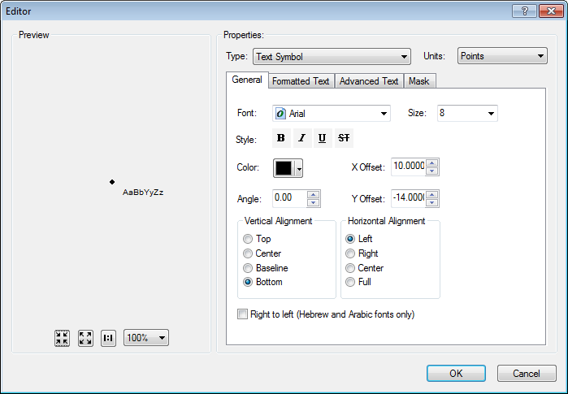
   3. Click “OK” to close this window.
   4. Click “OK” again. If changes were made, read and accept the warning.
   5. Under “Placement Properties”, verify the settings below.   
        
      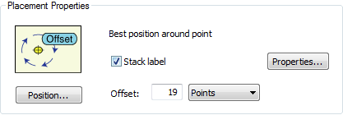
   6. Click “Expression” next to the Label Field dropdown.



* 1. Ensure that the “Display coded value description” checkbox is selected  
     
  2. Match the label text with the text below, click verify, and then click “OK”.

Function FindLabel ( [SubtypeCD] , [CCRating] )

If [SubtypeCD] = "Overhead Switch" and [CCRating] = "600A" then

FindLabel = [CCRating]

elseif [SubtypeCD] = "Overhead Switch" and [CCRating] = "800A" then

FindLabel = [CCRating]

End if

End Function

* 1. Click “Apply” but do not close the window.

1. Click on the *Default* annotation class to begin modifying its attributes.  
   1. Under “Text Symbol”, click the “Symbol” button. Then click “Edit Symbol”.
   2. Ensure that the settings under the “General” tab match the example below:   
        
      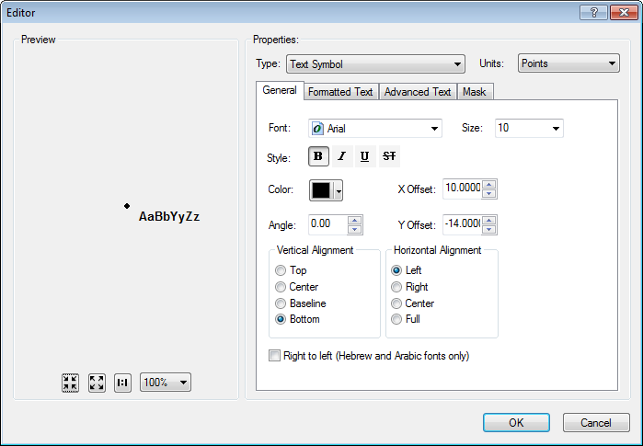
   3. Click “OK” to close this window.
   4. Click “OK” again. If changes were made, read and accept the warning.
   5. Under “Placement Properties”, verify the settings below.   
        
      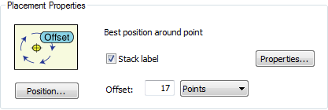
   6. Click “Expression” next to the Label Field dropdown.



* 1. Ensure that the “Display coded value description” checkbox is selected  
     
  2. Match the label text with the text below, click verify, and then click “OK”.

Function FindLabel ( [SubtypeCD], [OperatingNumber], [Class] ,[ComplexDeviceIdc] )

if [SubtypeCD] = "Overhead Disconnect" and [ComplexDeviceIdc] = "No" Then

FindLabel = [OperatingNumber] + chr(129) + vbCrLf + "SB" + vbCrLf + chr(129)

elseif [SubtypeCD] = "Overhead Switch" and [Class] = "II" Then

FindLabel = [OperatingNumber] + " II" + vbCrLf + chr(129)

else

FindLabel = [OperatingNumber] + vbCrLf + chr(129)

End if

End Function

* 1. Click “Apply” but do not close the window.

1. Click on the *Job* annotation class to begin modifying its attributes.  
   1. Under “Text Symbol”, click the “Symbol” button. Then click “Edit Symbol”.
   2. Ensure that the settings under the “General” tab match the example below:   
        
      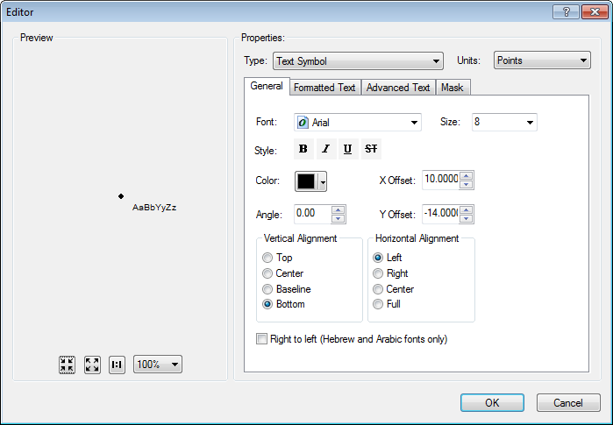
   3. Click “OK” to close this window.
   4. Click “OK” again. If changes were made, read and accept the warning.
   5. Under “Placement Properties”, verify the settings below.   
        
      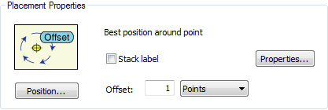
   6. Click “Expression” next to the Label Field dropdown.



* 1. Ensure that the “Display coded value description” checkbox is **unchecked**.  
     
  2. Match the label text with the text below, click verify, and then click “OK”.

Function FindLabel ( [INSTALLJOBPREFIX] , [INSTALLJOBNUMBER] , [INSTALLJOBYEAR], [SUBTYPECD], [CCRATING] )

pad = vbCrLf + chr(129)

If [SubtypeCD] = "Overhead Switch" then

if [CCRating] = "600A" or [CCRating] = "800A" then

pad = ""

end if

End if

myString = ""

if isNull( [INSTALLJOBNUMBER] ) or [INSTALLJOBNUMBER] = "0" or _

instr(ucase( [INSTALLJOBNUMBER] ), "CEDSA") then

else

if left(ucase( [INSTALLJOBPREFIX]), 3 ) <> "UNK" and _

ucase( [INSTALLJOBPREFIX] ) <> "FIF" and _

len( [INSTALLJOBPREFIX] ) > 0 then

myString = [INSTALLJOBPREFIX]

end if

if len( [INSTALLJOBYEAR] ) > 0 then

if len( [INSTALLJOBYEAR] ) = 4 then

FindLabel = myString + [INSTALLJOBNUMBER] + " '"+ right( [INSTALLJOBYEAR] ,2) + vbCrLf + chr(129) + pad

elseif len( [INSTALLJOBYEAR] ) = 2 then

FindLabel = myString + [INSTALLJOBNUMBER] + " '"+ [INSTALLJOBYEAR] + vbCrLf + chr(129) + pad

end if

else

FindLabel = myString + [INSTALLJOBNUMBER] + vbCrLf + chr(129) + pad

end if

end if

End Function

* 1. Click “Apply” and “OK”.

## Modify VoltageRegulatorAnno

1. Open ArcCatalog.
2. Within the Catalog Tree, expand “Database Connections” and open the active connection for this process (as defined in section 2).
3. Within the ElectricDataset, right-click on the “VoltageRegulatorAnno” annotation feature class and click “Properties”.
4. Click on the “Annotation Classes” tab.  
   .
5. Click on the *Default* annotation class to begin modifying its attributes.  
   1. Under “Text Symbol”, click the “Symbol” button. Then click “Edit Symbol”.
   2. Ensure that the settings under the “General” tab match the example below:   
        
      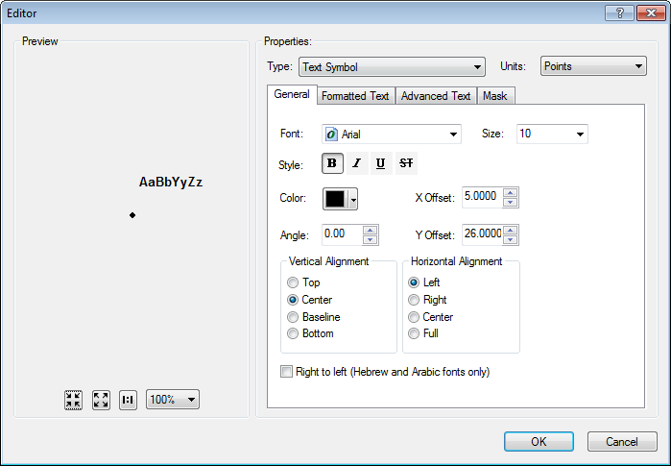
   3. Click “OK” to close this window.
   4. Click “OK” again. If changes were made, read and accept the warning.
   5. Under “Placement Properties”, verify the settings below.   
        
      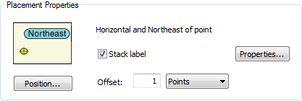
   6. Click “Apply” but do not close the window.
6. Click on the *Job* annotation class to begin modifying its attributes.  
   1. Under “Text Symbol”, click the “Symbol” button. Then click “Edit Symbol”.
   2. Ensure that the settings under the “General” tab match the example below:   
        
      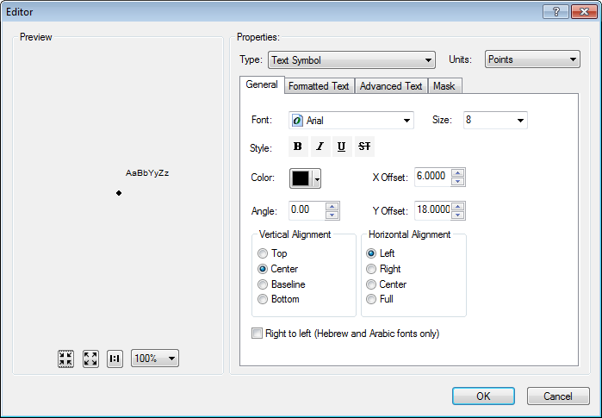
   3. Click “OK” to close this window.
   4. Click “OK” again. If changes were made, read and accept the warning.
   5. Under “Placement Properties”, verify the settings below.   
        
      
   6. Click “Expression” next to the Label Field dropdown.



* 1. Ensure that the “Display coded value description” checkbox is selected  
     
  2. Match the label text with the text below, click verify, and then click “OK”.

Function FindLabel ( [INSTALLJOBPREFIX], [INSTALLJOBNUMBER], [INSTALLJOBYEAR] )

myString = ""

if isNull( [INSTALLJOBNUMBER]) or [INSTALLJOBNUMBER] = "0" or _

instr(ucase( [INSTALLJOBNUMBER]), "CEDSA") then

else

if left(ucase( [INSTALLJOBPREFIX]), 3 ) <> "UNK" and _

ucase( [INSTALLJOBPREFIX]) <> "FIF" and _

len( [INSTALLJOBPREFIX]) > 0 then

myString = [INSTALLJOBPREFIX]

end if

if len( [INSTALLJOBYEAR]) > 0 then

if len( [INSTALLJOBYEAR]) = 4 then

FindLabel = myString + [INSTALLJOBNUMBER] + " '"+ right( [INSTALLJOBYEAR],2) + vbCrLf + chr(129)

elseif len( [INSTALLJOBYEAR]) = 2 then

FindLabel = myString + [INSTALLJOBNUMBER] + " '"+ [INSTALLJOBYEAR]+ vbCrLf + chr(129)

end if

else

FindLabel = myString + [INSTALLJOBNUMBER]+ vbCrLf + chr(129)

end if

end if

End Function

* 1. Click “Apply” but do not close the window.

1. Click on the *Size* annotation class to begin modifying its attributes.  
   1. Under “Text Symbol”, click the “Symbol” button. Then click “Edit Symbol”.
   2. Ensure that the settings under the “General” tab match the example below:   
        
      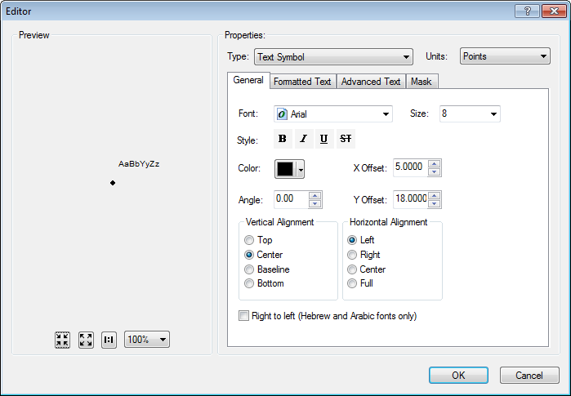
   3. Click “OK” to close this window.
   4. Click “OK” again. If changes were made, read and accept the warning.
   5. Under “Placement Properties”, verify the settings below.   
        
      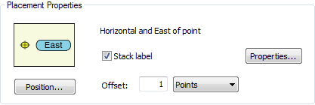
   6. Click “Expression” next to the Label Field dropdown.



* 1. Ensure that the “Display coded value description” checkbox is selected  
     
  2. Match the label text with the text below, click verify, and then click “OK”.

Function FindLabel ([UnitCount], [RatedAmps] )

If [UnitCount]> 1 then

FindLabel = [UnitCount]& "-" & [RatedAmps]& vbCrLf & chr(129)

else

Findlabel = [RatedAmps]& vbCrLf & chr(129)

End if

End Function

* 1. Click “Apply” and “OK”.

## Modify SupportStructureAnno

1. Open ArcCatalog.
2. Within the Catalog Tree, expand “Database Connections” and open the active connection for this process (as defined in section 2).
3. Within the ElectricDataset, right-click on the “SupportStructureAnno” annotation feature class and click “Properties”.
4. Click on the “Annotation Classes” tab.
5. Click on the *Default* annotation class to begin modifying its attributes.  
   1. Under “Text Symbol”, click the “Symbol” button. Then click “Edit Symbol”.
   2. Ensure that the settings under the “General” tab match the example below:   
        
      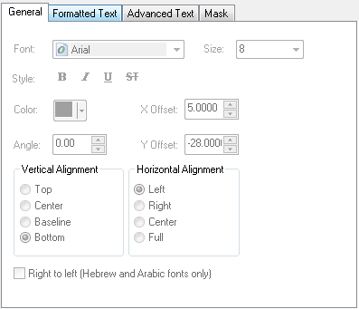
   3. Click “OK” to close this window.
   4. Click “OK” again. If changes were made, read and accept the warning.
   5. Under “Placement Properties”, verify the settings below.   
        
      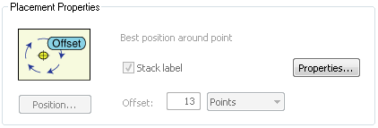
   6. Click “Expression” next to the Label Field dropdown.



* 1. Ensure that the “Display coded value description” checkbox is **unchecked**.  
     
  2. Match the label text with the text below, click verify, and then click “OK”.

Function FindLabel ( [SubtypeCD], [Height] , [Material], [JPNUMBER] )

MyString = ""

If [SubtypeCD] = 1 then

If ucase([Material]) = "WOOD" then

myMaterial = ""

elseif ucase( [MATERIAL] ) = "STEL" then

myMaterial = "ST"

elseif ucase( [MATERIAL] ) = "FIBR" then

myMaterial = "FG"

else

myMaterial = [MATERIAL]

end if

myString = [HEIGHT] +"' " + myMaterial

elseif [SubtypeCD] = 5 or [SubtypeCD] =4 or [SubtypeCD] = 2 or [SubtypeCD] = 8 then

MyString = [Height] + "' "

End If

FindLabel = MyString + vbCrLf + chr(129)

End Function

* 1. Click “Apply” but do not close the window.

1. Click on the *JobNumber* annotation class to begin modifying its attributes.  
   1. Under “Text Symbol”, click the “Symbol” button. Then click “Edit Symbol”.
   2. Ensure that the settings under the “General” tab match the example below:   
        
      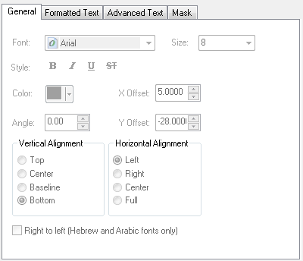
   3. Click “OK” to close this window.
   4. Click “OK” again. If changes were made, read and accept the warning.
   5. Under “Placement Properties”, verify the settings below.   
        
      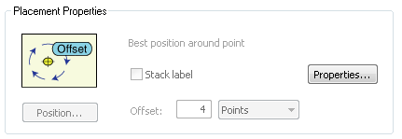
   6. Click “Expression” next to the Label Field dropdown.



* 1. Ensure that the “Display coded value description” checkbox is **unchecked**.  
     
  2. Match the label text with the text below, click verify, and then click “OK”.

Function FindLabel ( [INSTALLJOBPREFIX] , [INSTALLJOBNUMBER] , [INSTALLJOBYEAR] )

myString = ""

if isNull( [INSTALLJOBNUMBER] ) or [INSTALLJOBNUMBER] = "0" or _

instr(ucase( [INSTALLJOBNUMBER] ), "CEDSA") then

else

if left(ucase( [INSTALLJOBPREFIX]), 3 ) <> "UNK" and _

ucase( [INSTALLJOBPREFIX] ) <> "FIF" and _

len( [INSTALLJOBPREFIX] ) > 0 then

myString = [INSTALLJOBPREFIX]

end if

if len( [INSTALLJOBYEAR] ) > 0 then

if len( [INSTALLJOBYEAR] ) = 4 then

FindLabel = myString + [INSTALLJOBNUMBER] + " '"+ right( [INSTALLJOBYEAR] ,2) + vbCrLf + chr(129)

elseif len( [INSTALLJOBYEAR] ) = 2 then

FindLabel = myString + [INSTALLJOBNUMBER] + " '"+ [INSTALLJOBYEAR] + vbCrLf + chr(129)

end if

else

FindLabel = myString + [INSTALLJOBNUMBER] + vbCrLf + chr(129)

end if

end if

End Function

* 1. Click “Apply” and “OK”.

## Modify StepDownAnno

1. Open ArcCatalog.
2. Within the Catalog Tree, expand “Database Connections” and open the active connection for this process (as defined in section 2).
3. Within the ElectricDataset, right-click on the “StepDownAnno” annotation feature class and click “Properties”.
4. Click on the “Annotation Classes” tab.
5. Click on the *Job* annotation class to begin modifying its attributes.  
   1. Under “Text Symbol”, click the “Symbol” button. Then click “Edit Symbol”.
   2. Ensure that the settings under the “General” tab match the example below:   
        
      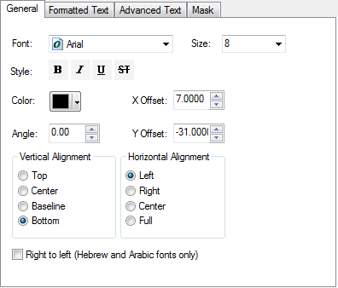
   3. Click “OK” to close this window.
   4. Click “OK” again. If changes were made, read and accept the warning.
   5. Under “Placement Properties”, verify the settings below.   
        
      
   6. Click “Expression” next to the Label Field dropdown.



* 1. Ensure that the “Display coded value description” checkbox is **checked**.  
     
  2. Match the label text with the text below, click verify, and then click “OK”.

Function FindLabel( [InstallJobPrefix], [InstallJobNumber], [InstallJobYear], [INSTALLATIONTYPE])

myString = ""

pad = vbCrLf + chr(129)

if [INSTALLATIONTYPE] = "Overhead" then

pad = vbCrLf + chr(129) + vbCrLf + chr(129)

end if

if isNull( [INSTALLJOBNUMBER] ) or [INSTALLJOBNUMBER] = "0" or _

instr(ucase( [INSTALLJOBNUMBER] ), "CEDSA") then

else

if left(ucase( [INSTALLJOBPREFIX]), 3 ) <> "UNK" and _

ucase( [INSTALLJOBPREFIX] ) <> "FIF" and _

len( [INSTALLJOBPREFIX] ) > 0 then

myString = [INSTALLJOBPREFIX]

end if

if len( [INSTALLJOBYEAR] ) > 0 then

if len( [INSTALLJOBYEAR] ) = 4 then

FindLabel = myString + [INSTALLJOBNUMBER] + " '"+ right( [INSTALLJOBYEAR] ,2) + pad

elseif len( [INSTALLJOBYEAR] ) = 2 then

FindLabel = myString + [INSTALLJOBNUMBER] + " '"+ [INSTALLJOBYEAR] + pad

end if

else

FindLabel = myString + [INSTALLJOBNUMBER] + pad

end if

end if

End Function

* 1. Click “Apply” but do not close the window.
  2. Verify that the following screens match what is seen in ArcCatalog. If there is a difference, please change ArcCatalog to match the screenshot.
     1. Under “Placement Properties”, click “Properties” and select the “Label Position” tab.
     2. 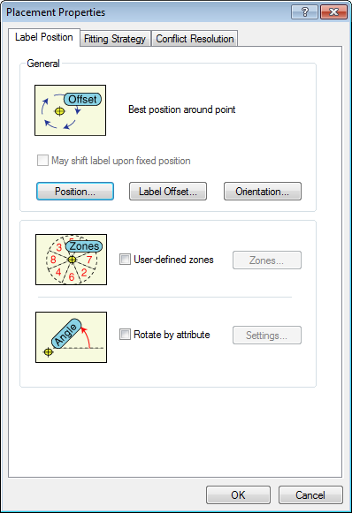Click “Label Offset”  
        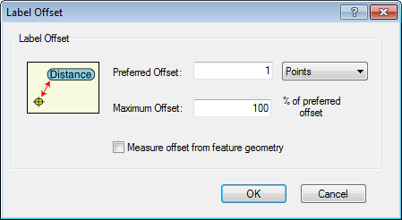
     3. Click “OK” if any changes were made. Click “Label Orientation”.  
        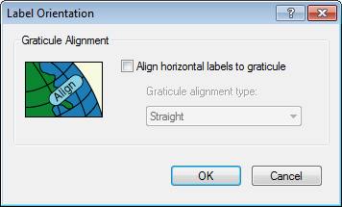
     4. Click “OK” if any changes were made. Click the “Fitting Strategy” tab.  
        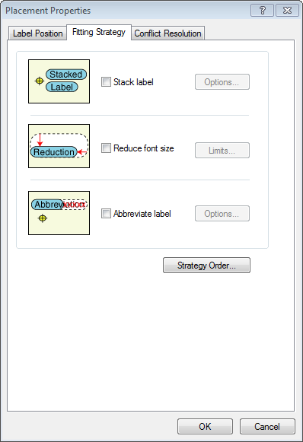
     5. Click “Strategy Order”.  
        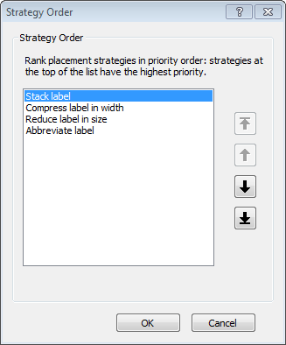
     6. Click “OK” if any changes were made. Click the “Conflict Resolution” tab.  
        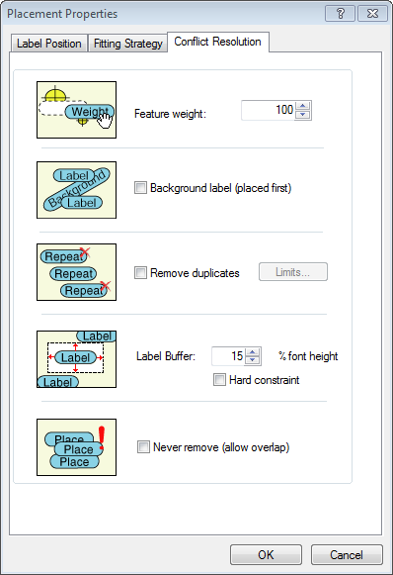
     7. Click “OK” if any changes were made. You should be back to the “Feature Class Properties” main window. Click “OK” to close the window.

1. Click on the *Default* annotation class to begin modifying its attributes.
   1. Click the “Bold” button so that it is pressed down.  
      
   2. Click “OK”.
2. Click on the *Job* annotation class to begin modifying its attributes.  
   1. Under “Text Symbol”, click the “Symbol” button. Then click “Edit Symbol”.
   2. Set the Vertical Alignment to “Center”.  
      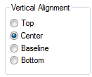

# ArcFM XML Import

1. Open ArcCatalog.
2. Within the Catalog Tree, expand “Database Connections” and open the active connection for this process (as defined in section 2).
3. Right-click on the database and select “ArcFM XML Import” **or** select the ArcFM Import button on the ArcFM toolbar  cid:image001.png@01CE88A1.C6001750
4. Import all XML files in the current EDER release folder (\\sfetgis-nas01\sfgispoc_data\ApplicationDevelopment\TelventDeliverables\EDER v3.2.1\ArcFM Exports) using the following criteria:

* If the database **will** **not** be used for production, import all “Non Production” XML files.
* If the database **will** be used for production, import all “Non Production” XML files except for “ArcFM Properties.xml”. Then import all “Production” XML files.  
  1. Use the Overwrite option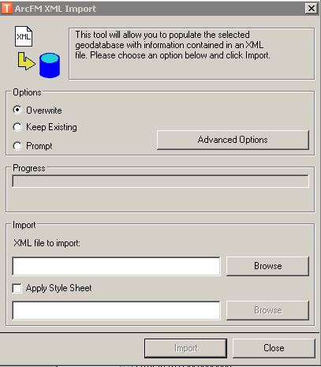Browse to the XML file, choose the “Overwrite” option, then click on the Import button.

# Update Data Model Version Table

**Database Configuration:**

1. Open SQL Plus.
2. Log in using the same server and user as was used in section 2.  
     
   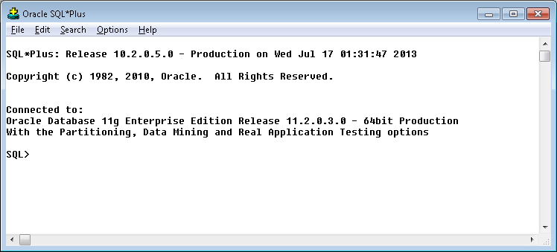
3. Run the SQL below:

update pgedatamodelversion set currentidc='N' where currentidc='Y';

insert into pgedatamodelversion (OBJECTID, CURRENTIDC, DATEAPPLIED, APPLIEDBYPERSONNAME, MODELVERSION) values (29,'Y',sysdate,'Don Peaslee','7.5.6 GOLD CR9036');

# Run Annotation Scripts

1. Navigate to the following folder and run the annotation scripts inside the folder by following the instructions in the README.txt.

\\sfetgis-nas01\sfgispoc_data\ApplicationDevelopment\IBM_TeamMembers\CoreyBlakeborough\AUConveyor_1.4.1_DM7.5.6

# Known Issues

<Please List any other issues encountered here while following the document>